FORECASTING THE FINANCIAL HEALTH OF A BUSINESS USING PENALIZED REGRESSION

  - Financial Health of a Business

  - Importance of Forecasting Financial Health of the Business

    - The Influence of Borrowing on Financial Health

    - Debt Ratio and Borrowing Ability

  - Importance of Knowing Financial Health for Lenders

    - Poor Financial Health: Bankruptcy

  - Importance of Knowing a Business’s Financial Health for Investors

  - Forecasting Financial Health

    - Financial Ratios

  - Multicollinearity

    - Testing for Multicollinearity

  - Using Penalized Regression for Evaluating Financial Health

    - Predicting Financial Health Using LASSO

    - Business Insights and Other Applications

  - Implementation Using R: Evaluating the Health of a Business

  - Appendix: Glossary of Financial Terms

  - Understanding the Chapter

LEARNING OBJECTIVES
- Gauge the financial health of a business
- Understand the importance of bankruptcy forecasting for investors, lenders, and businesses

- Use penalized regression for forecasting financial health
- Determine multicollinearity and feature selection with LASSO

FINANCIAL HEALTH OF A BUSINESS
In any firm, the finance department serves the important functions of control, planning, decision-making, and ensuring regulatory compliance. The department provides a backward look at how the business performed by examining many financial reports, including balance sheets, income statements, and cash flow statements that indicate to the business where its strengths and weaknesses lie. It also provides an important forward look in the form of many forecasts, including cash flow forecasts, scenario planning, and sensitivity analysis. Forecasting (or prediction) models are very commonly used in finance to inform lenders, the business itself, and several different types of investors where they need to invest their resources in the coming time periods. These forecasts also consider credit ratings, market conditions, and the broader economic outlook. Where should a business invest? Should it increase prices or offer promotions? Can it provide employee raises, or is it time to cut costs? Can it invest in a new location or a new product? Financial management provides an overall look at the financial health of a firm, helping in strategic decision-making across various departments. Therefore, financial forecasting helps provide business leadership with an overall picture to develop strategies that avoid decision-making silos. Such forecasting also helps lenders determine whether to offer a loan and helps business borrowers determine how much they should borrow.

IMPORTANCE OF FORECASTING FINANCIAL HEALTH OF THE BUSINESS
Different entities in the firm need to determine the financial health of the business since it is a critical input in their decisions. Owners and management need to know how the business is performing its main functions to determine which areas need further investment versus which areas might need to be divested. Incorrect forecasts or erroneously ambitious ventures can result in resources running out and ventures having to be terminated midstream at great financial, organizational, and human cost. General Electric started more than 100 years ago as an electric and electronic product manufacturing company but was able to grow into many different areas—including GE Capital, a financial services branch.
However, after the financial crisis of 2008, regulatory pressures, and the unprofitable acquisition of French transportation company Alstom’s power business in 2015, GE had to divest its financial division after management determined that further investment in this division would be problematic for GE’s other divisions.

Employees also need to be aware of their organization’s financial health for a variety of reasons. Knowledge of the company’s financial standing helps in assessing job security and in making informed career planning decisions. Awareness of organizational finances also fosters motivation and can align individual objectives with the organization’s goals. Transparent communication about financial health also nurtures an environment of trust, facilitating better understanding of management decisions, including those concerning incentives, compensation, and organizational changes.

The Influence of Borrowing on Financial Health
Determining financial health is important for a business so that it can understand whether it needs to borrow money, how much to borrow, and at what interest rate; it also needs to identify which areas are growth areas that merit further investment. Many businesses cannot operate without borrowing.
Borrowing helps grow the business, but it also adds costs in terms of interest payments. The interest payable on debt provides a tax shield on the taxable amount. For instance, if the tax rate is 30% and the

interest expense is $1,000, then a business receives a tax shield of $300 (interest expense × tax rate). In fact, trade-off theory in finance suggests that there is a trade-off between the tax shield provided by debt and the financial distress of not being able to repay the debt. If we avoid the extremes, trade-off theory will predict that risky businesses focused on intangible assets, such as technology startups, will have less debt compared to businesses that own tangible assets such as hotels. Companies want to maintain an optimal debt ratio to ensure that lenders and investors don’t lose faith in them. Therefore, one way to assess the value of a business is to consider its market value as dependent on its equity and debt.

Market value = Equity + tax shield from debt – cost of financial distress

The trade-off theory can be illustrated as shown in Figure 10.1.

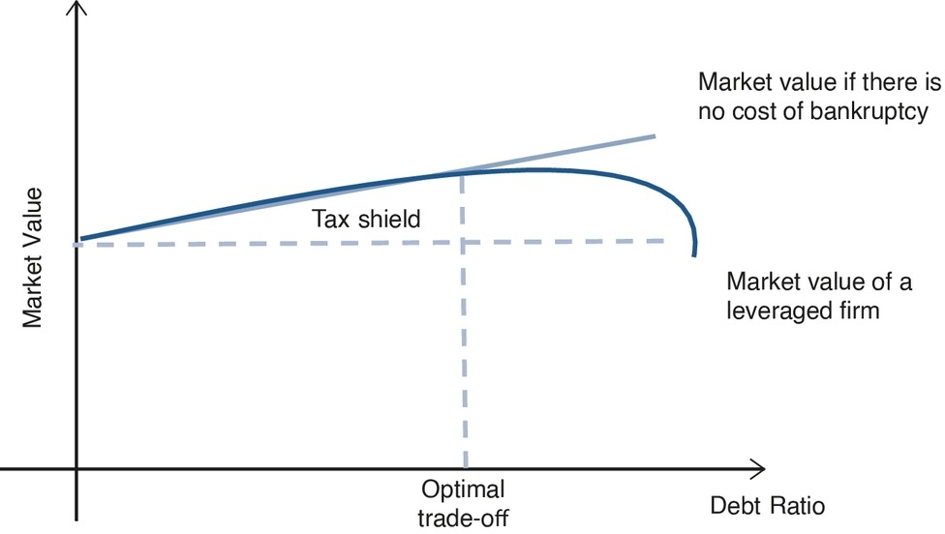
Description

Figure 10.1 Tax Shield Provided by Debt Versus the Financial Distress

Debt Ratio and Borrowing Ability
As can be seen from Figure 10.1, a business that operates just on equity and is not dependent on debt is not influenced either by the tax shield or by the chance of financial distress because of debt. It can face distress for other reasons but not because of its inability to pay back debt. Let’s look at the curve and the straight line. The curve shows a leveraged business—that is, one that has taken a loan and owes a debt to its lenders. We can see that initially, when the debt amount is low, the business gets a tax shield for the debt. Given the low debt, the business may not be facing a huge amount of debt servicing (i.e., paying back the principal and interest for each period of the loan). Please refer to Section 10.9: Glossary of Financial Terms for definitions. If the business goes to the market to borrow, the lenders will use the debt ratio of the business to evaluate its financial health. A low debt ratio can help the business borrow at a lower rate of interest. This reduced interest can help it grow and do well, which in turn can increase its market value. The business can also borrow more. The more its debt increases, the more its tax shield will grow initially. Everything is fine as long as the tax shield is able to offset the probability of financial distress because of the firm’s debt servicing costs. However, the probability of financial distress becomes quite high when the debt servicing crosses a threshold where the tax shield is not able to match the level of borrowing. Borrowing beyond this point results in greater likelihood not only of financial distress but also of bankruptcy.

Consider Sears, which declared bankruptcy after being in business for 125 years and having at one time enjoyed the title of the largest retailer in the United States. Over the years, Sears accumulated

significant debt, which, coupled with operational inefficiencies and strategic missteps, led to financial distress. While debt can sometimes offer leverage and tax shields, in Sears’s case, it became a burden, reducing its financial health. Sears tried to raise cash by closing hundreds of its stores as a cost-cutting measure. This laid off thousands of workers and caused distress to its employees. The inability to keep up with the technological changes resulted in Sears slowly falling behind. Several post hoc theories have been suggested for its demise, including lack of investment to modernize offline stores and not investing in a strong online presence. The demise of this previously formidable retailer shows that knowing the financial health of a business and strategically basing its borrowing on its ability to pay off the debt in a timely manner is important for all company stakeholders.

IMPORTANCE OF KNOWING FINANCIAL HEALTH FOR LENDERS
Lenders can be banks or any financial institution that lends money to businesses for different activities. Lenders need to evaluate the financial health of a business before they determine whether to lend to a business, ensuring that the business will remain solvent and pay off its debt. Lenders need to continuously evaluate the creditworthiness of the borrower over the period of the loan. Usually, a lender evaluates the total assets of a business against its total liabilities, as stated in the balance sheet, to determine its financial health. As we discuss in detail later, several financial and operating ratios are used for this purpose. Businesses with good financial health are considered more creditworthy and are likely to qualify for a loan, while businesses with poor financial health may be denied a loan or may obtain it only at a significantly higher interest rate. A good credit rating—for example, a triple-A rating— allows a business to borrow from lenders at a lower rate. Conversely, a higher interest rate indicates that the lender does not consider the business to be particularly creditworthy and is charging the higher rate as insurance against the possibility that the business will default on its loan payment. In extreme cases, as we discuss in Section 10.4.1 on private equity, a business in financial distress can borrow only at very high interest rates.

It is not surprising that lenders take these precautions because businesses can start experiencing financial difficulties through factors unfolding in their macroenvironment (e.g., the financial crisis of 2008) or because of their own past decisions (e.g., GE deciding to buy Alstom or Toys “R” Us having accumulated significant debt while facing increased competition from online retailers and changing consumer preferences). When a business continues to experience financial difficulties, bankruptcy looms as a possibility.

Poor Financial Health: Bankruptcy
If the business continues to experience financial difficulties, such as those we can see in Figure 10.1, it will start to default on its loan payments, resulting in increased financial distress. Such distress is a cause of concern for lenders, who have to decide whether additional investment is warranted in an attempt to reverse the distress or to allow further defaults by the business. In such cases, businesses can declare bankruptcy. Bankruptcy is the legal acknowledgment by the business that it is unable to pay off its debts. Businesses file for either Chapter 7 or Chapter 11. In a Chapter 11 filing, a business can be restructured in such a way that it gets another chance. If it subsequently does well, it can pay off its debts and work its way out of bankruptcy. For instance, Toys “R” Us filed for Chapter 11 in 2017, hoping that it would be able to restructure the company and pay off its debts. However, it was not able to do so and had to file for Chapter 7 in 2018. Chapter 7 filing does not allow the business to continue to operate; in such cases the business will cease to exist. One form of Chapter 7 bankruptcy occurs when all assets of the business are liquidated so that some of its debts can be paid off. In situations where the business owners cannot pay back their debts, then the lenders step in and take over whatever is left of the business.

There are numerous examples of companies that were successful at one time later experiencing financial distress. For example, David’s Bridal, a large wedding dress retailer with a presence in several states, found that changing tastes and focus on nontraditional dresses by millennials resulted in lowered profits and an inability to pay their debt. Mattress Firm filed for Chapter 11, shutting down approximately 900 stores in 2018. It struggled with adapting to changes introduced in mattress manufacture and competition from startups such as Tuft & Needle, Casper, and Purple. Online mattress purchases have seen a huge spike, even though mattresses were touted as a product that consumers need to physically feel and experience prior to purchase. This resulted in Mattress Firm needing to reconsider how it offers its product to consumers who no longer feel the need to try out a mattress before purchasing it.

All lenders do not face the same decision of whether to let a business file for bankruptcy. It depends on the type of business. For example, consider lenders to two businesses: a restaurant versus a biotech startup. Initially, both need the same level of investment from the lenders. If a few years later both companies file for bankruptcy, the situation from the point of view of the lender will differ. In the case of the restaurant, the entire setup is still functional, and an easy option for the lender is to get someone else to run the restaurant. However, in the case of the biotech startup, the space or the setting is unimportant; the investment is in human capital and what it can produce—the ideas and innovations that are generated by the employees. If the biotech does not do well, then what can the lender salvage?
Unfortunately, not much.

IMPORTANCE OF KNOWING A BUSINESS’S FINANCIAL HEALTH FOR INVESTORS
A business can have different types of investors. For instance, it might have venture capitalists investing in it during the initial stage of development. In later stages, several financial institutions, including private equity firms, may invest or buy stakes in the business. This allows them to have a say in the working of the business—for example, which divisions to identify for growth versus divestment. Finally, if the company is traded on the stock market, individual investors also are interested in knowing the financial health of a business to determine whether and how much to invest in it. Depending on the level of investment—for example, a financial institution investing millions versus an individual investor purchasing one share of stock for a few dollars—investors can utilize different means to understand whether and how much to invest. Again, the financial health of a business, assessed by using different types of financial ratios, becomes the means to determine the level of investment. In certain circumstances, when investors might assess that a business has potential but is not performing optimally, they might buy a major stake to have a greater say in operations. Private equity is one such type of investor. Private equity firms tend to invest in businesses that have unrealized potential but are struggling financially, possibly because of high debt; make them grow rapidly; and—if (as predicted) the business does have unrealized potential—reap the benefits.

Hence, it is important for the business, lenders, and investors to accurately identify whether a business does have the potential to grow or whether the trajectory of financial distress is likely to continue. An entire area in finance is devoted to understanding and predicting what variables can be used to predict whether a business is going to experience financial distress or, in extreme cases, go bankrupt.

FORECASTING FINANCIAL HEALTH
Several predictors have been considered that can help predict creditworthiness. Let’s understand this using an example from the perspective of a lender such as a bank. When a business approaches a bank asking for a loan, the bank is likely to utilize several criteria to first determine the financial health of the business and then decide whether or not to give a loan. Let’s assume that a bank wants to determine variables that can help it assess the financial health of the business. Let’s also assume that the bank is being conservative in its estimate and defines creditworthiness in terms of future financial

distress or possibility of bankruptcy. It can focus on financial as well as nonfinancial predictors, but many times lenders prefer to look at financial predictors to understand the financial health of a business.

Financial Ratios
Businesses report several financial ratios that help lenders evaluate their financial health, such as debt‒ equity ratio, current ratio, earnings ratio, and operating ratio. These ratios are commonly available on the balance sheet of a business’s financial statements. Please see the detailed definitions of these ratios in the glossary provided in Section 10.9 of this chapter.

For any type of forecasting, businesses tend to use a process of variable selection to sort the relevant from the irrelevant variables. If a business knows which variables are relevant, it can use only those variables in its forecasting models. Another reason for variable selection is to improve the accuracy of predictions; better predictions result in less costly mistakes. Similarly, when predicting financial health, it is important to perform variable selection to find the relevant predictors to use in prediction models.
Moreover, many financial predictors tend to be correlated, some of them quite highly; this causes some predictors to appear significant when they are not—that is, the presence of collinear predictors results in incorrect predictions. Let’s understand what multicollinearity is.

MULTICOLLINEARITY
Collinearity occurs when two predictor variables are highly correlated. Multicollinearity occurs when several such variables are present in the dataset. Multicollinearity can occur for a variety of reasons in business data, such as when predictors are dependent on the same underlying cause or when data collection is observational. In our case, since financial ratios are based on financial indicators, the likelihood of multicollinearity is high. Multicollinearity causes the following issues. First, when multicollinearity exists in a regression model, it may not be appropriate to use ordinary least squares (OLS) regression. This is because OLS assumes that the predictor variables are independent—that is, uncorrelated (in fact, predictor variables are called independent variables for this reason). The presence of multicollinearity makes it difficult to interpret the coefficient estimates of individual predictors. Recall from Chapter 2 in which we discussed linear regression that we used beta coefficients to determine whether a predictor variable had a significant influence on the outcome variable. If several of the predictors are highly correlated, the influence of a specific predictor on the outcome (e.g., significance level) will change depending on which predictors are included in the regression model, resulting in incorrect assessments from the analysis. Second, one of the assumptions of OLS is that we examine the change in the outcome variable for a unit change in the predictor, holding all other predictors constant. However, if two predictors are highly correlated, such an assumption would not be fulfilled.
Moreover, if our aim is to find which predictors are the most versus least influential, multicollinearity will make the task difficult. Third, as the correlation among predictors increases, standard errors also increase because it becomes difficult to determine whether the variation in the outcome is caused because of predictor 1 or predictor 2. Therefore, the standard error of both predictors increases. High incidents of standard error make it difficult to reject the null hypothesis even though the null may be false. Therefore, the likelihood of Type I error increases (i.e., the inability to reject a false null hypothesis). Finally, multicollinearity can result in an overfitted model because of the inclusion of two predictors that are very similar in the way they relate to the output. An overfit model would be quite inaccurate and poorly generalizable while making predictions on a new dataset. This occurs because the model has learned spurious relations given the multicollinearity present in the original dataset that may not be present in the new dataset on which the model is asked to predict. A bit needs to said about the bias‒variance trade-off to understand the problem caused by overfit models (please refer to the Technical Appendix for a detailed discussion of the bias–variance trade-off). When we have an overfit model, the bias of the model is low because it fits the training data really well; however, the variance of the model is high because it doesn’t predict well on the new data.

Testing for Multicollinearity
Given the possibility of multicollinearity occurring when using financial variables to determine the financial health of a business, we need a method that can address multicollinearity as well as help in the selection of variables. The first step is to have a method to detect whether a dataset has multicollinear predictors. The simplest way to test for multicollinearity is by looking at the scatterplot between different predictor variables. A linear relationship between any two predictors indicates a high degree of correlation between them. Similarly, a correlation matrix between all the predictors would quantify the level of correlation among the predictors. Large changes in beta coefficient estimate values depending on when one or the other predictor is or is not included in the regression could be another indication of multicollinearity. For instance, if earnings ratio had a high coefficient estimate value when current ratio was not included but the coefficient value was reduced significantly in magnitude when current ratio was included in the regression, this would indicate a high correlation between earnings ratio and current ratio.

Finally, the variance inflation factor (VIF) is used to quantify the level of multicollinearity. VIF is a metric that helps in determining inflated variance of the beta coefficient for a specific predictor variable because of multicollinearity with other predictor variables. Stated differently, VIF tells us how much the variance (the spread of predictor values) is inflated due to these correlations. Since VIFs capture the relationship among predictor variables, the VIF is calculated by regressing each predictor against every other predictor. Such a regression will provide an R² value, which is then put into the following equation for the ith predictor:

1/(1 − R²)
i
As you may recall, R² is the coefficient of determination in an OLS regression model that informs us how well the predictor(s) is(are) able to predict the outcome variable. In this case, R² indicates how well other predictors are able to predict the ith predictor.

Hence, we can calculate the value of VIF for each predictor variable. There are some cutoffs that help us evaluate whether the correlation between the predictors is very high. For instance, a VIF of 1.7 for a predictor indicates that the variance of that predictor’s estimate is 1.7 times what it would have been in the absence of multicollinearity. A VIF of 3.5 indicates 3.5 times more variation. A simple rule of thumb is that VIF values of more than 5 indicate high multicollinearity.

One way to address multicollinearity is through the use of stepwise regression. However, this can get computationally inefficient. Hence, in this chapter we discuss the use of penalized regression, which provides an efficient way to handle multicollinearity through variable selection.

USING PENALIZED REGRESSION FOR EVALUATING FINANCIAL HEALTH
One type of regression that can address issues of multicollinearity is called penalized regression. It introduces a penalty that penalizes the model for having too many predictor variables. Either the predictors may be less relevant, or they may be correlated. Penalized models shrink the beta-coefficient estimates of the less relevant predictors so that they can either be removed or have very little impact in predicting the outcome variable.

The functional/mathematical formulation of penalized regression allows it to work differently than OLS regression. For example, we use a set of predictor variables in the OLS model to predict an outcome. We then compare the predicted value to the actual value (ground truth) to examine the quality of the OLS model’s predictions. If the difference is high, the quality is poor; if the difference is low, the quality is

good. Therefore, we try to minimize the difference between the actual and predicted values. As explained earlier, one issue with multicollinearity is that it results in a model that is overfit; it explains the training data well, but its predictions on test (i.e., new) data are quite poor.

Penalized regression addresses this situation by adding a shrinkage penalty to the beta-coefficient estimates of the predictors. The shrinkage penalty fits a new prediction model that introduces a small amount of bias but greatly reduces the variance. With the addition of the shrinkage, the output intuitively becomes less sensitive to changes in the value of the predictor; hence, there is less variance when the model is used to make predictions on a new dataset. For the purposes of this chapter, we will focus on a specific type of penalized regression—LASSO (Least Absolute Shrinkage and Selection Operator)¹— which not only helps to address multicollinearity but also allows for variable selection. The other form of penalized regression is ridge regression, which does not help in variable selection. Specifically, the penalty term used in the LASSO helps shrink the coefficient estimates of the less important predictors to
zero. When the beta coefficients of some predictor variables have been shrunk to zero, they are no longer included in the prediction model. Hence, this process serves as a variable selection method for LASSO.

Let’s assume that we have i = 1 to n observations and j = 1 to p predictors and their corresponding beta coefficients.

Linear regression minimizes the difference between the observed outcome values and predicted outcome values as captured in the following equation:

n p
2
∑ (yi − ∑ βjxij)
i=1 j=1

In LASSO, we add the penalty term

λ|β_{j}|
to the minimization equation of the linear regression. Hence, in LASSO we minimize:

n p 2 p
∑ (yi − ∑ βjxij) + λ ∑|βj|

i=1
j=1
j=1

When λ = 0, LASSO converts to OLS. As the value of λ increases, the penalty increases, and the value of the coefficient estimates shrinks to zero. That is, λ controls the value of the penalty that is applied to the regression. The value of λ can vary from 0 to positive infinity.
Another intuitive way to think about the shrinkage penalty is to think of c(β) as the cost applied by penalized regression on the size of the β coefficients. β coefficients determine how much the estimated
outcome values deviate from the observed values (i.e., the deviance between the data and the model). Adding a penalty on the size of the β coefficients and forcing them to be near zero improves prediction.

LASSO is especially useful when a model includes several predictor variables and the business is not able to decide which of these are relevant and which are not. Consider a grocery store with outlets across several geographic regions. There are many predictors that can affect the sale of fresh baked goods, including the presence of local bakeries, the cost of eggs (which could change by region), the cost of milk, the cost of transportation, the nearness of farms, population density around a specific store, income level, regionally popular flavors—and the list can keep going. Which of these are the most important predictors of sales for a specific store? By using LASSO for variable selection, the grocery store can determine which sales predictors are important and can focus its resources on these relevant

predictors. LASSO can also solve the problem of one form of Big Data—when there are more predictors than observations. In such an instance, OLS regression will not converge because it needs at least as many observations as predictors. If the data have two predictors, then the OLS needs at least two observations or data points to converge (provide a solution). In instances when firms are not sure about which predictors are most relevant, they may include tens of predictors and would need at least as many observations for the OLS to work.

Let’s use a specific example to understand how LASSO can help in predicting the financial health of businesses from the perspective of a lender.

Predicting Financial Health Using LASSO
Let’s consider the example of Altra Bank, a made-up example for the purposes of this chapter that lends to several businesses and, hence, needs to know the financial health of each so that it can determine whether the business will be able to pay back the debt amount or whether it is likely to default on its payments. Having information about the financial health of a business allows Altra Bank to decide whether to give a loan and how much interest to charge. During its more than 50 years in this business, Altra Bank has determined that the financial health of a business rarely changes overnight and that any changes for the worse can be detected through certain predictors. Moreover, Altra Bank has observed that the financial ratios of a business, as calculated from the balance sheet, are good predictors of financial health.

In the past, Altra Bank has used these financial ratios to find out which businesses it has lent to need to be monitored more closely. However, recently it has learned that ratios including operating variables such as sales are also worth considering when forecasting the financial health of a business. Therefore, it obtained data containing 16 different ratios for 665 businesses that have good versus poor financial health. The metric in the data for assessing financial health is whether a business has or has not gone bankrupt. The data contain information on several financial ratios such as debt–equity ratio, current ratio, and operating ratio for businesses that did or did not go bankrupt. Similar to other lenders, Altra Bank also uses data on these ratios to build a model that can help it make predictions about the financial health of the businesses it is determining whether to lend to or not. Altra Bank also wants to determine whether some ratios are better predictors than others; hence, having data with labels of whether a business went bankrupt is very useful in building the model. (The data used in this example are hypothetical.)

The data have the following 16 financial ratios, some of which are operational ratios, marketing ratios, or accounting ratios.

current_ratio_1 = current assets / short-term liabilities

earning_ratio_1 = EBIT (earnings before interest and taxes) / total assets debt_equity_ratio_1 = book value of equity / total liabilities accounting_ratio_1 = total assets / total liabilities
operating_ratio_1 = (inventory * 365) / sales marketing_ratio_1 = net profit / sales
operating_ratio_2 = profit on operating activities / financial expenses marketing_ratio_2 = (total liabilities − cash) / sales

current_ratio_2 = (current assets − inventories) / long-term liabilities current_ratio_3 = (current assets − inventory − receivables) / short-term liabilities operating_ratio_3 = profit on operating activities / sales
current_ratio_4 = (current assets − inventory) / short-term liabilities

earning_ratio_2 = EBITDA (earnings before interest, taxes, depreciation, and amortization—i.e., [profit on operating activities − depreciation] / total assets)

current_ratio_5 = current assets / total liabilities debt_equity_ratio_2 = long-term liabilities / equity operating_ratio_4 = total costs / total sales

Using the data, we can begin to do several tests and then build the model. The first test we will conduct is to examine whether the data include collinear predictors (i.e., whether a high correlation, either positive or negative, exists among some of the 16 predictors). We obtain a correlation plot as shown in Figure 10.2. As expected of financial ratios, the plot shows that quite a few ratios are correlated more than 0.5 with one another. For example, marketing_ratio_1 and earnings_ratio_2 are correlated −0.97 with each other.

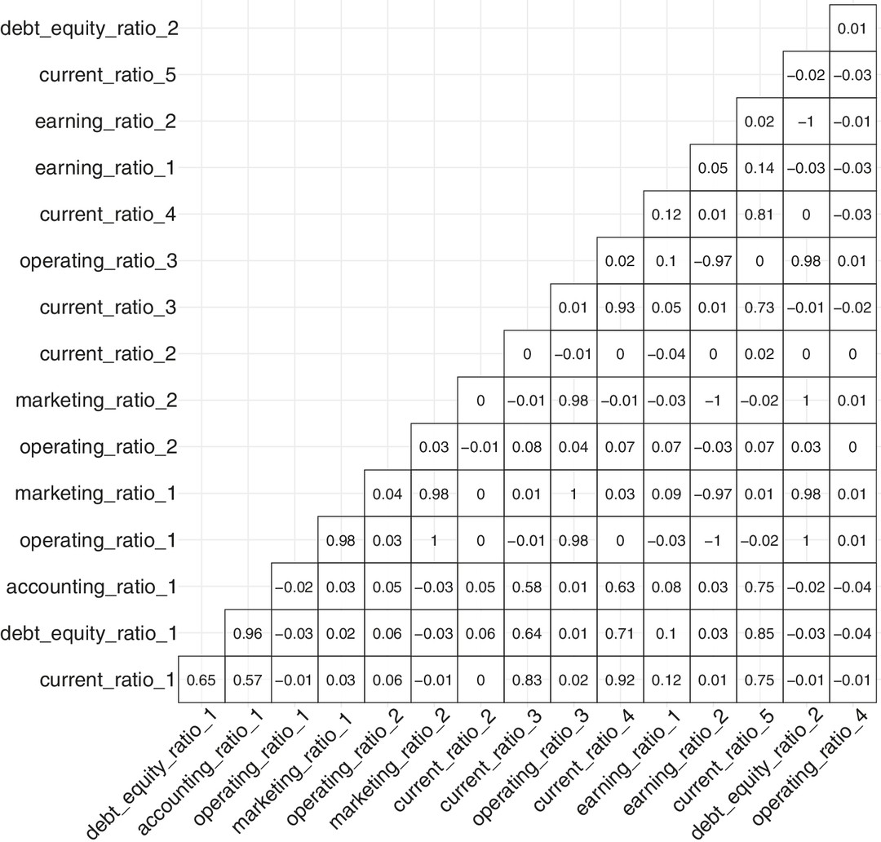

Figure 10.2 Correlation Plot

Next we can check for multicollinearity using the VIF for each of the predictors.

## | current_ratio_1 | debt_equity_ratio_1 | accounting_ratio_1 | operating_ratio
## | 4.565160 | 614.931070 | 624.345293 | 1.969324
## | marketing_ratio_1 | operating_ratio_2 | marketing_ratio_2 | current_ratio
## | 11.756341 | 1.083820 | 2.825103 | 1.338527
## | current_ratio_3 | operating_ratio_3 | current_ratio_4 | earning_ratio
## | 2.346815 | 27.912590 | 3.912966 | 2.240309
## | earning_ratio_2 | current_ratio_5 | debt_equity_ratio_2 | operating_ratio
## | 24.330196 | 3.678511 | 2.641648 | 1.019840

The VIF of some of the financial ratios is very high (e.g., debt_equity_ratio_1 = 614.93 and accounting_ratio_1 = 624.34).

Now that we have established that some of the financial ratio predictors that we plan to use in our model are highly correlated, we can use penalized regression. We use LASSO to first perform a variable selection as to which are the best predictors of financial health.

We next define the outcome variable: yes, a business will go bankrupt versus no, a business will not go bankrupt. We use penalized logistic regression because the dependent variable is binary in nature (yes/no).

Since the outcome is binary, we will use the AUC ROC (area under the curve receiver operating characteristics) curve to examine the quality of predictions of the LASSO model. AUC is the ratio between a false positive (firms that did not go bankrupt but are identified by the model as having gone bankrupt) and a true positive (firms that went bankrupt and are identified by the model as having gone bankrupt). Higher values of AUC are better because they indicate whether the model is able to distinguish between the yes and no outcomes. AUC = 1 indicates that the model is able to correctly classify yes as yes and no as no. AUC = 0.8 means that 80% of the time the model will classify yes and no correctly. AUC = 0.5 means that the model cannot distinguish between yes and no and is considered random in its predictions. AUC = 0 means that the model is reversing its predictions completely and classifying yes as no and no as yes.

In the training dataset, we can also plot the AUC values for different values of log(λ). In Figure 10.3, we can see that the best values of AUC are those of log(λ) between −8 and about −9. The values on top of the graph indicate the number of dummy-coded predictors being used.

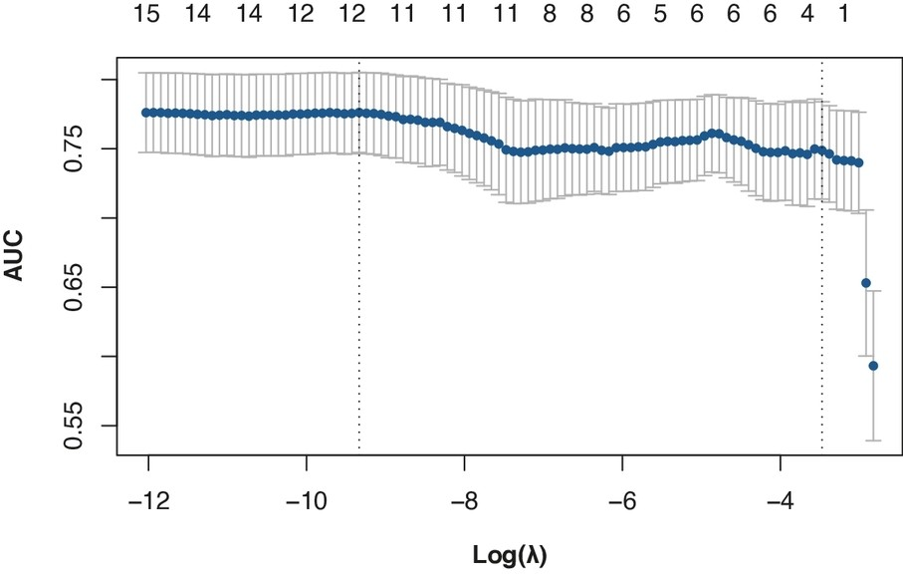

Figure 10.3 AUC Values for Different Values of Log(λ)

In order to run a penalized regression prediction model, we split the data into train and test sets. We then run a LASSO on the train set to perform variable selection. We also standardize the data to ensure that they are easy to interpret. It is important to note that if we don’t standardize values, LASSO can result in extreme values and difficulty in comparing predictors that may be measured on different units. We then run LASSO, which outputs beta coefficient values for all 16 predictors but shrinks the beta coefficients of predictors it considers less relevant to zero.

From the output, we can see that the LASSO model we ran using 16 predictors has shrunk the beta- coefficient values of 4 predictors to zero. In other words, it has selected 12 predictors as being relevant for predicting the outcome variable: financial health.

## [1] 8.837698e-05
## 17 x 1 sparse Matrix of class "dgCMatrix"
## | s1
## (Intercept) | 1.346913e+01
## current_ratio_1 | 9.231917e-02
## debt_equity_ratio_1 | 1.297786e+01
## accounting_ratio_1 | -1.416379e+01
## operating_ratio_1 | .
## marketing_ratio_1 | 3.031253e+00
## operating_ratio_2 | 3.493792e-03
## marketing_ratio_2 | .
## current_ratio_2 | -1.985339e-05
## current_ratio_3 | 2.416489e+00
## operating_ratio_3 | -4.810050e+00
## current_ratio_4 | -2.503380e+00
## earning_ratio_1 | 4.965877e-01

## earning_ratio_2 | .
## current_ratio_5 | 7.127187e-01
## debt_equity_ratio_2 | .
## operating_ratio_4 | 9.021487e-03

We have trained our penalized regression model. But the important part is seeing how useful it is for prediction. We next use the model and examine how well it performs on data in a separate test.

To evaluate the quality of the LASSO model’s predictions and because the outcome is binary, we consider the AUC ROC curve (Figure 10.4). The AUC ROC curve is calculated (and plotted) as the ratio between false positives (firms that did not go bankrupt but are identified as having gone bankrupt) on the x-axis and true positives (firms that went bankrupt and are identified as having gone bankrupt) on the y-axis. If the model predicts poorly, then the value of AUC will be low since AUC increases as the predictive ability of the model improves. That is, higher values indicate better prediction.

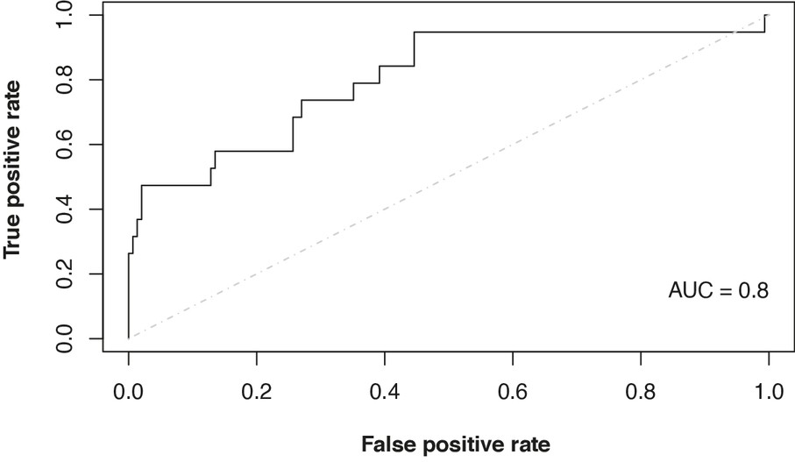

Figure 10.4 AUC ROC Curve
Description

Now that we have developed a model with the most relevant predictor variables (i.e., ratios), let’s see how Altra Bank can use this model to determine the financial health of a business that has requested a loan. If the financial ratio values for the business are as shown in the following table, Altra Bank can use the predictive LASSO model to determine whether the business is likely to go bankrupt. Note, since the model was trained using a yes/no outcome, it will predict in a similar manner: Given these ratios, it will predict that yes, the business will go bankrupt or no, the business will not go bankrupt.

## lambda.min
## [1,] "0"
current_ratio_1 | debt_equity_ratio_1 | accounting_ratio_1 | operating_ratio_1
1.65 | 0.85 | 1.79 | 17.31
marketing_ratio_1 | operating_ratio_2 | marketing_ratio_2 | current_ratio_2
0.084 | 22.81 | 0.269 | 0.517
current_ratio_3 | operating_ratio_3 | current_ratio_4 | earning_ratio_1
0.179 | 0.205 | 1.75 | 0.198

earning_ratio_2 | current_ratio_5 | debt_equity_ratio_2 | operating_ratio_4
0.09 | 1.27 | 0.75 | 0.075

We provide the trained LASSO model with the financial ratios of the new firm and ask the model to generate a prediction. The prediction value of 0 means that our model is predicting that this business will go bankrupt. Given this prediction, Altra Bank can now decide whether to go ahead with a loan.

Business Insights and Other Applications
Therefore, using a penalized regression model, we can build predictive models even if the data are collinear—a common problem when using financial ratios as predictors. Note that linear and logistic regression’s estimates are affected by the presence of multicollinearity—resulting, for example, in the model’s inability to reject a false null hypothesis. However, penalized regression can provide estimates even in the presence of multicollinearity. It handles correlation among predictors through the inclusion of the shrinkage penalty that helps find the model of best fit even in the presence of multicollinearity. In terms of business insights, using LASSO, in this chapter we developed a penalized regression model that can help lenders allocate loans and businesses determine their financial health.

In addition to selecting which variables are the most important to determine the financial health of an organization, LASSO can be used in other areas of finance such as assets optimization by selecting the critical assets that can result in an optimal asset portfolio. It can also be used for fraud detection in financial transactions—by finding the variables that help financial organizations identify which transactions do not appear regular and could, hence, be fraudulent. Moving beyond the financial sector, LASSO can be used to identify the most important variables to predict employee satisfaction or for optimal inventory management or effective campaigns that maximize customer engagement.

IMPLEMENTATION USING R: EVALUATING THE HEALTH OF A BUSINESS
The data contain 16 financial ratios, some of which are marketing related and some accounting related as mentioned earlier. First we read in the data on the 16 predictor variables and the libraries: ROCR,² glmnet,³ psycho,⁴ tidyverse,⁵ ggplot2,⁶ and car.⁷

library(ROCR)
library(glmnet)
trainData <- read.csv(url("http://data.mishra.us/files/train_bankruptcy.csv"))
testData <- read.csv(url("http://data.mishra.us/files/test_bankruptcy.csv"))
predictors <- trainData[,c(1:16)]
bankruptcy <- trainData$class
We then check for the correlation among the 16 predictor variables. R provides the correlation plot as shown in Figure 10.2. As we can see from the plot, there are quite a few ratios that are correlated more than 0.5 with one another.
library(psycho)

library(tidyverse)
library(ggcorrplot)
correl <- cor(predictors)
ggcorrplot(correl,hc.order=FALSE,
type="lower",lab=TRUE,lab_size = 5,
outline.color = "black",tl.cex = 17,
colors = c("white", "white"))+
theme(legend.position = "none")

Next we can check for multicollinearity using VIF for each of the predictors.

library(ggplot2)
library(car)
predictionModel <- glm(as.factor(trainData$class) ~ .,
 |  | data = trainData,family=binomial(link='logit'))
vif(predictionModel)
## | current_ratio_1 | debt_equity_ratio_1 | accounting_ratio_1 | operating_ratio
## | 4.565160 | 614.931070 | 624.345293 | 1.969324
## | marketing_ratio_1 | operating_ratio_2 | marketing_ratio_2 | current_ratio
## | 11.756341 | 1.083820 | 2.825103 | 1.338527
## | current_ratio_3 | operating_ratio_3 | current_ratio_4 | earning_ratio
## | 2.346815 | 27.912590 | 3.912966 | 2.240309
## | earning_ratio_2 | current_ratio_5 | debt_equity_ratio_2 | operating_ratio
## | 24.330196 | 3.678511 | 2.641648 | 1.019840

The VIF of some of the financial ratios is very high (e.g., debt_equity_ratio_1 = 614.93 and accounting_ratio_1 = 624.34). Because some financial ratios are highly correlated and we are dealing with a binary outcome (yes, a business will go bankrupt versus no, a business will not go bankrupt), we use penalized logistic regression.

The model.matrix function helps to dummy code the categorical (yes/no) variable so that the glmnet
function can use the values. The function also helps create a matrix of the predictor variables.

To examine the quality of predictions of the LASSO model, we look at the AUC ROC curve. AUC is the ratio between false positive and true positive. Higher values of AUC are better because in our case they indicate whether the model is able to distinguish between the yes and no outcomes. In the training dataset, we can also plot the AUC values for different values of log(λ). From the plot in Figure 10.3, we can see that the best values of AUC are those of log(λ) between −12 and about −9. The values on top of the graph indicate the number of dummy-coded predictors used.

predictors <-data.matrix(predictors)
set.seed(1287994)

cv.binomial <- cv.glmnet(x = predictors, y = as.factor(bankruptcy),
alpha=1, family="binomial",
nfolds=4, standardize = TRUE, type.measure = "auc")
plot(cv.binomial)

We then use the glmnet function to run the penalized regression. Since we are running a penalized logistic regression, we specify that it is binomial. The term alpha helps us specify whether we want to run a LASSO or ridge regression: alpha = 1 will execute a LASSO while alpha = 0 will run a ridge regression. Since in this case we are interested in variable selection, we will run a LASSO. Remember that although we do shrink predictor coefficient estimates to near zero with ridge, it still uses all predictors, which makes it difficult to choose variables with ridge regression.
Recall that the shrinkage parameter λ can vary between zero and infinity. To find the optimal value of λ, we use cross-validation. Here we conducted a four-fold cross-validation. We also standardize the data to ensure that they are easy to interpret; more important, the developers of LASSO suggest that not standardizing can result in extreme values and difficulty in comparing predictors that may be measured on different units. Finally, we also ask R to output the optimal value of λ, which is called lambda.min.
We can then find out which predictors LASSO shrunk to 0 using the lambda.min parameter. We see that it has shrunk the β parameters of 4 of the predictors to zero and, hence, selected 12 from the initial 16 predictors.

(best.lambda <- cv.binomial$lambda.min) ## [1] 8.837698e-05
y4<- coef(cv.binomial, s="lambda.min", exact=FALSE) print(y4)
## | 17 x 1 sparse Matrix of class "dgCMatrix"
## |  | s1
## | (Intercept) | 1.346913e+01
## | current_ratio_1 | 9.231917e-02
## | debt_equity_ratio_1 | 1.297786e+01
## | accounting_ratio_1 | -1.416379e+01
## | operating_ratio_1 | .
## | marketing.ratio_1 | 3.031253e+00
## | operating_ratio_2 | 3.493792e-03
## | marketing_ratio_2 | .
## | current_ratio_2 | -1.985339e-05
## | current_ratio_3 | 2.416489e+00
## | operating_ratio_3 | -4.810050e+00
## | current_ratio_4 | -2.503380e+00
## | earning_ratio_1 | 4.965877e-01
## | earning_ratio_2 | .
## | current_ratio_5 | 7.127187e-01

## debt_equity_ratio_2 | .
## operating_ratio_4 | 9.021487e-03

We have trained our penalized regression model. But the important part is seeing how well it can be used in prediction. We now use the trained model with the optimal value of λ and evaluate how it performs on a separate test dataset.

test_predictors <- testData[,c(1:16)]
test_predictors <- data.matrix(test_predictors)
pred = predict(cv.binomial, newx = test_predictors,
type = "response",s ="lambda.min")
pred <- prediction(pred, testData$class)
perf <- performance(pred,"tpr","fpr")
auc_ROCR<- performance(pred,measure ="auc")

We again use the AUC ROC curve to examine the prediction of the LASSO model on the test dataset. This is calculated (and plotted) as the ratio between false positives on the x-axis and true positives on the y-axis. Higher AUC values indicate better model prediction. Figure 10.4 plots this curve.

plot(perf,colorize=FALSE, col="black") # plot ROC curve
lines(c(0,1),c(0,1),col = "gray", lty = 4 )
text(1,0.15,labels=paste("AUC = ", round(auc_ROCR@y.values[[1]],
digits=2), sep=""),adj=1)

Using the trained model, we can now use it to predict whether a business will go bankrupt. If we provide the values of the 16 financial ratios of a new business to the model, it will provide a prediction of 0 (will go bankrupt) or 1 (will not go bankrupt).

current_ratio_1 | debt_equity_ratio_1 | accounting_ratio_1 | operating_ratio_1
1.65 | 0.85 | 1.79 | 17.31
marketing_ratio_1 | operating_ratio_2 | marketing_ratio_2 | current_ratio_2
0.084 | 22.81 | 0.269 | 0.517
current_ratio_3 | operating_ratio_3 | current_ratio_4 | earning_ratio_1
0.179 | 0.205 | 1.75 | 0.198
earning_ratio_2 | current_ratio_5 | debt_equity_ratio_2 | operating_ratio_4
0.09 | 1.27 | 0.75 | 0.075

We enter these data as new_data. Since for glmnet the data have to be in the form of a matrix, we convert it to a matrix with one row (nrow = 1) and 16 columns (ncol = 16). For the predict function, we use type = class so that the output is in the form of a class (will face bankruptcy
= 0 versus will not face bankruptcy = 1) with the highest predicted probability.

new_data = c(1.65,0.85, 1.79,
17.31,0.084,22.81,0.269,.517,0.179,0.205,
1.75,0.198,0.09,1.27,0.75,0.075)

new_data <- matrix(new_data, nrow = 1, ncol = 16, byrow = TRUE)
pred = predict(cv.binomial, newx = new_data,
type = "class", s ="lambda.min")
pred
## lambda.min
## [1,] "0"

The value 0 means that our model predicts that this business will eventually go bankrupt. Altra Bank can use the model’s predictions to determine whether to offer the business a loan.

APPENDIX: GLOSSARY OF FINANCIAL TERMS

Balance Sheets: Financial statements that provide an overview of a company’s assets, liabilities, and shareholders’ equity at a certain point in time.

Bankruptcy: A legal process in which a person or business declares the inability to repay outstanding debts. It can offer some protection from creditors and provide a way to reorganize or liquidate assets.

Borrow Money: To obtain funds from a lender with the promise of repaying it in the future, usually with interest. The person borrowing money is also called a debtor.

Chapter 7: A type of bankruptcy under U.S. Bankruptcy Code that involves the liquidation or selling of a debtor’s nonexempt assets to pay off creditors.

Chapter 11: A type of bankruptcy under U.S. Bankruptcy Code that allows businesses to continue operating while they restructure their debt obligations and business affairs and plan for the future under the guidance of the bankruptcy court.

Credit Ratings: A rating given to a business or individual that indicates their creditworthiness or ability to repay borrowed funds. One credit rating agency is Standard and Poor’s (S&P).

Current Ratio: This ratio considers the relationship between current assets (the assets that can be easily converted into cash, such as inventory) and current liabilities (e.g., short-term debts, dividend payments, and taxes). It is a measure of the liquidity of a business (defined as the ease with which an asset can be converted into cash without affecting its market value). Current ratio helps lenders determine how equipped the business is in terms of repaying its debts, especially its short-term debt payments. A higher current ratio (current assets to current liabilities) indicates higher liquidity. A current ratio of 2 is said to indicate sound financial health, while anything less than 1 can constitute a warning sign.

Debt–Equity Ratio: This ratio evaluates the relationship between liabilities of the business (what it owes; specifically long-term debts, which appear on the right side of the balance sheet) and shareholder equity (total assets minus total liabilities). It is one of the most common ratios used to evaluate the health of a business. What is considered a good debt–equity ratio depends on the industry—values nearer 1 are generally considered better. As the value of the debt–equity ratio increases beyond 1, it indicates that the business is more dependent on debt financing than on its

own equity. Problems arise when the reliance on debt keeps increasing, meaning the likelihood of financial distress increases.

Debt Ratio: A financial metric that compares a company’s total debt to its total assets, used to evaluate financial risk.

Debt Servicing: The process of making principal and interest payments on borrowed funds over time.

Default: Failure to fulfill the repayment of a loan, including interest or principal, at the agreed-upon terms and time.

Earnings ratio: This ratio is the current earnings of a firm and captures the financial performance of a business before taking into account taxes and other liabilities. It allows investors to look at how the business is performing every year because of the operating decisions made for that year; it does not take into account financial decisions that carry over from previous years such as interest and taxes. Thus, it provides a good picture of a business’s net income or profit in a given year.

Economic Outlook: An analysis or opinion regarding the future state of the economy or economic conditions.

Equity: The value of ownership interest in a business, calculated by deducting liabilities from assets.

Financial Distress: A condition in which a company faces difficulties in meeting its financial obligations, such as paying off debt.

Financial Health: The overall economic status of a business, including its income, expenses, debts, and long-term sustainability.

Financial and Operating Ratios: Metrics used to evaluate a business’s financial health and operational efficiency.

Growth Areas: Parts or aspects of a business showing potential for expansion or development.

Intangible Assets: Nonphysical assets like patents, copyrights, and brand reputation or image that add value to a business.

Interest Payments: Money paid to a lender by a borrower as compensation for the use of borrowed funds, usually calculated as a percentage of the principal amount.

Interest Rate: The percentage charged by a lender to a borrower for using their money. The borrower pays this in addition to repaying the borrowed amount (the principal).

Lenders: Individuals or institutions that give a temporary loan or credit to borrowers with the expectation it will be paid back with interest.

Leveraged Business: A company that has used borrowed capital (debt) to increase the potential return on equity.

Leveraged Buyout (LBO): A financial transaction where a company is purchased using a combination of equity and significant amounts of borrowed money, often using the company’s assets as collateral.

Market Value: The estimated amount for which a business or asset could be sold by a willing buyer to a willing seller.

Operating Costs: Expenses related to the business’s primary operations, such as the costs of materials, labor, and overhead. These costs are deducted from a company’s revenue to calculate its operating profit.

Operating Efficiency: The performance of a business in terms of its use of resources to produce goods and services. A high operating efficiency means that a business utilizes its resources wisely, resulting in higher profits.

Operating Ratio: This indicates the operating efficiency of a business by considering the relationship between operating costs (the costs incurred in the day-to-day operations of the business) and sales (the amount earned by selling products and services). In other words, it examines whether the business has been able to keep costs low compared to how much it is selling. A lower operating ratio is considered better and indicates greater efficiency.

Optimal Debt Ratio: A balance of debt and equity that maximizes a company’s value while minimizing its cost of capital.

Regulatory Compliance: Adhering to laws, regulations, guidelines, and specifications relevant to the business’s processes and operations.

Scenario Planning: A strategic planning method used by organizations to make flexible long-term plans that can take into account possible future scenarios or events.

Solvency: Describes a business’s ability to meet its long-term financial obligations by having more assets than liabilities.

Tangible Assets: Physical assets such as machinery, buildings, and land that a business owns and uses in its operations.

Tax Shield: A reduction in taxable income for an individual or corporation achieved through claiming allowable deductions such as interest on debt.

Trade-Off Theory in Finance: A theory that suggests companies manage and balance the benefits and costs of debt financing, considering aspects such as tax shields and financial distress.

UNDERSTANDING THE CHAPTER
- Can a business keep taking loans because it provides a tax shield? Is there a problem that may arise if the loan amount because too high?
- Why should we not use OLS regression when there is multicollinearity in the data?
- Penalized regression is used to address which of the following issues?
  - Autocorrelation
  - Heteroscedasticity
  - Homoscedasticity
  - Multicollinearity
  - Lagged variables
- Which of the following statements regarding multicollinearity among predictors is false?
  - Variance inflation factor (VIF) values of more than 5 indicate multicollinearity.
  - Variance inflation factor (VIF) values of less than 5 indicate multicollinearity.
  - Bar charts cannot test for multicollinearity.
  - Variance inflation factor (VIF) can test for multicollinearity.
  - Scatterplots can indicate multicollinearity.
- Which of the following statements is true about filing for Chapter 7 bankruptcy?
  - The business can be restructured and turned around.

  - The process is similar to a Chapter 11 filing.
  - Most businesses do it every year.
  - The business ceases (stops) to operate.
  - Chapter 7 is applicable to individuals and not to businesses.
- Which of the following statements is true about filing for Chapter 11 bankruptcy?
  - The business can be restructured and turned around.
  - The process is similar to a Chapter 7 filing.
  - Most businesses do it every year.
  - The business ceases (stops) to operate.
  - Chapter 11 is applicable to individuals and not to businesses.
- Private equity is likely to acquire a business using leveraged buyout. Which of the following statements is false about leveraged buyout?
  - More than 90% of the loan has to be funded via equity.
  - More than 90% of the loan can be funded via debt.
  - The assets of the acquired business are used as collateral.
  - It is considered hostile by the acquired business.
  - It can result in restructuring the acquired business.

ENDNOTES

- Tibshirani, R., “Regression Shrinkage and Selection via the LASSO,” Journal of the Royal Statistical Society: Series B (Methodological) 58, no. 1 (1996): 267‒288.
- Sing T., O. Sander, N. Beerenwinkel, and T. Lengauer, “ROCR: Visualizing Classifier Performance in R,” Bioinformatics 21, no. 20 (2005): 3940–3941, http://rocr.bioinf.mpi-sb.mpg.de.

- Friedman, J., T. Hastie, and R. Tibshirani, “Regularization Paths for Generalized Linear Models via Coordinate Descent,” Journal of Statistical Software 33, no. 1 (2010): 1‒22, https://www.jstatsoft.org/v33/i01/.

- Makowski, D., “The Psycho Package: An Efficient and Publishing-Oriented Workflow for Psychological Science,” Journal of Open Source Software no. 3, 22 (2018): 470, https://github.com/neuropsychology/psycho.R.

- Wickham, H., et al., “Welcome to the tidyverse,” Journal of Open Source Software 4, no. 43 (2019): 1686, https://doi.org/10.21105/joss.01686.

- Wickham, H., ggplot2: Elegant Graphics for Data Analysis (New York: Springer-Verlag, 2016).

- Fox, J., and S. Weisberg, An R Companion to Applied Regression, 3rd ed. (Thousand Oaks, CA: Sage), https://socialsciences.mcmaster.ca/jfox/Books/Companion/.

Descriptions of Images and Figures
Back to Figure

The figure is a graph with y-axis labeled Market Value and x-axis labeled Debt Ratio at the end. Inside the graph from the center of y-axis and x-axis arises two dotted lines labeled Tax shield and Optimal trade-off, respectively intersecting each other. From the middle of the y-axis arises a linear line labeled Market value if there is no cost of bankruptcy and a smooth lagging curve labeled Market value of a leveraged firm.

Back to Figure

The figure consists of y-axis labeled True positive rate and marked 0.0, 0.2, 0.4, 0.6, 0.8, 1.0. X-axis is marked 0.0, 0.2, 0.4, 0.6, 0.8, 1.0 from left to right and labeled False positive rate. At the bottom right is AUC = 0.8. From the bottom left to top right is a dotted linear line. From bottom left to top right is a plot in the staircase model.

OceanofPDF.com

